Activity Suggestion: Make a Word Cloud
Provide a big sheet of paper or white board with a word or subject line. Ask people to write down three words that come to their mind in relation to that particular word. Use post it notes to place on the white board. Bit of work here then to put all the responses through one of the easily available Word Cloud Apps to create your own word cloud which is printable for display.
In the Word Cloud, the size of a word shows how important it is e.g. how often it appears in a text – its frequency. The word cloud shows the most common words in bigger size and it keeps going down in font size with least common response. Choose a subject line or topic as per what you want to bring the focus to …. again do share it with us all through the week.
An example: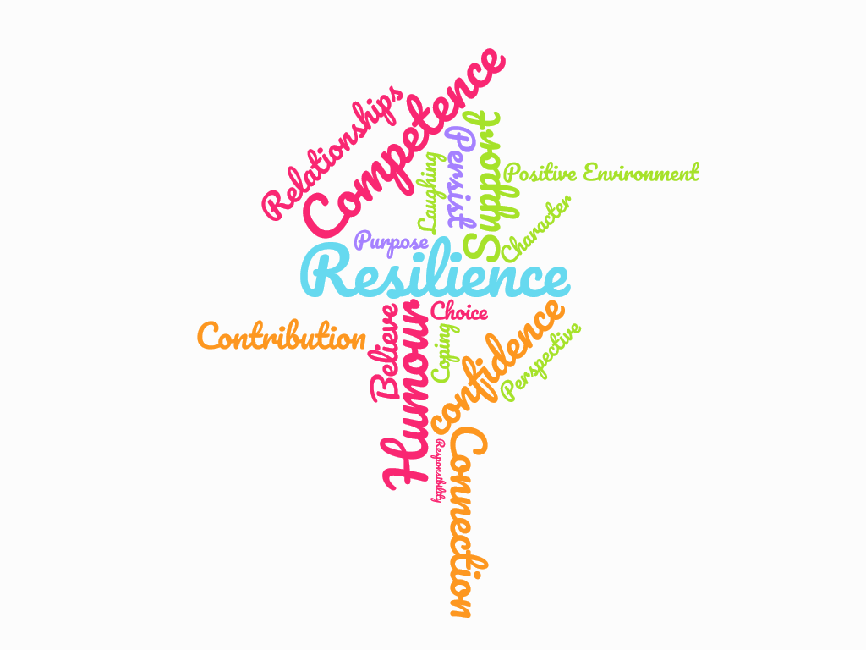Web search options:
https://www.wordclouds.com/
https://worditout.com/word-cloud/create
https://wordart.com/

HPSAANZ Awareness Week – March 8th -12th 2021

