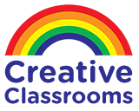
https://www.creativeclassrooms.co.nz/

Kids Personalised Stickers
Rating:
98% of100
4 Reviews Add Your Review
70 large stickers 7 designs per pack

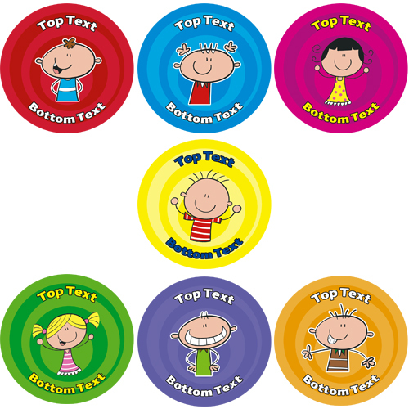
IN STOCK
Product Code
P205
$12.40$14.26
- Buy 2 for $10.10 each (excl. gst) and save 19%
- Buy 4 for $9.00 each (excl. gst) and save 27%
- Buy 6 for $8.10 each (excl. gst) and save 35%
- Buy 20 for $7.20 each (excl. gst) and save 42%

